1) Write a program to swap two values using tuple assignment.

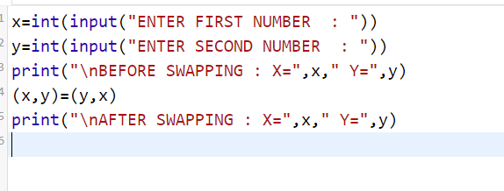

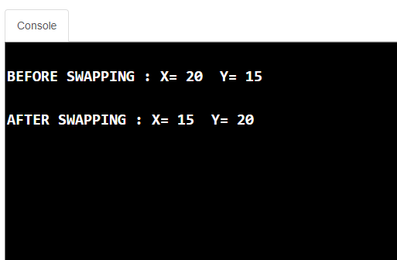

2. Write a program that scans an email address and forms a tuple of user name and domain.

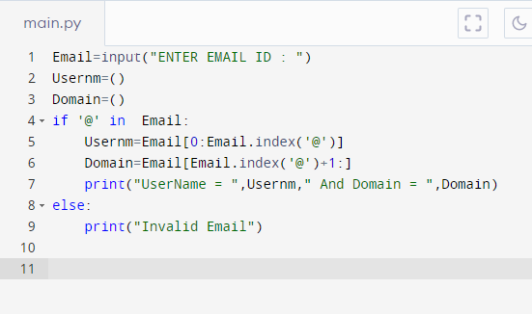

OUTPUT

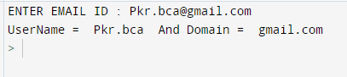

3. write a program that has a list of numbers (both positive and negative). Make a new tuple that has

only positive values from the list.

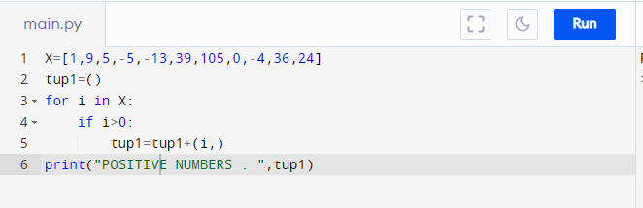

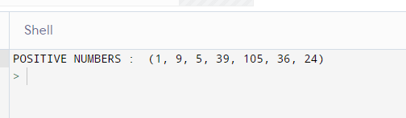

4. Write a program using nested tuple to store book details like “Title of book”, “Author name”, “Publisher name”, “Year of publication” and “Price”. Get the book title as input from user to search and display the details of the book.

Record=(("C","Kishor","Arrow",2020,190),

("C++","Ramesh","Bing",2021,195),

("JAVA","Mined","Lotus",2024,200),

("PYTHON","Suresh","zix",2021,195))

n= input ("ENTER TITLE TO SEARCH : ")

for i in Record:

if (i.count(n)):

print(i)

break

else:

print("Record Not Found")

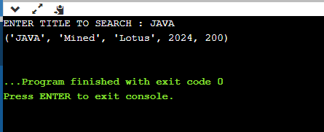

**SET**

1. Write a program that generates a set of prime numbers and another set of odd numbers. Demonstrate the result of union, intersection, difference and symmetric difference operations on these sets.

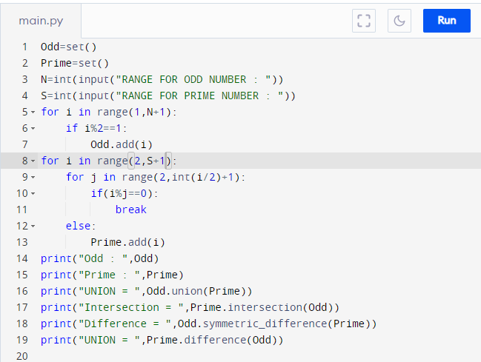

OUTPUT

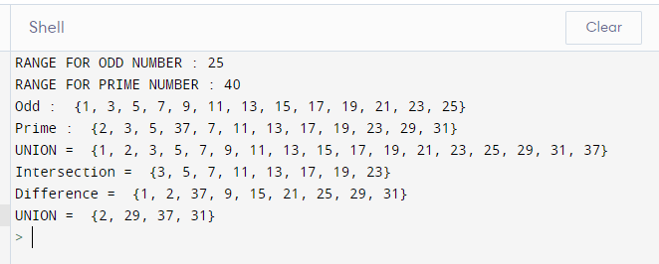

2) Write a program that creates two sets. One of even numbers in range 1-10 and the other has all composite numbers in range 1-20. Demonstrate the use of all(), issuperset(), len(), and sum() functions on the sets.

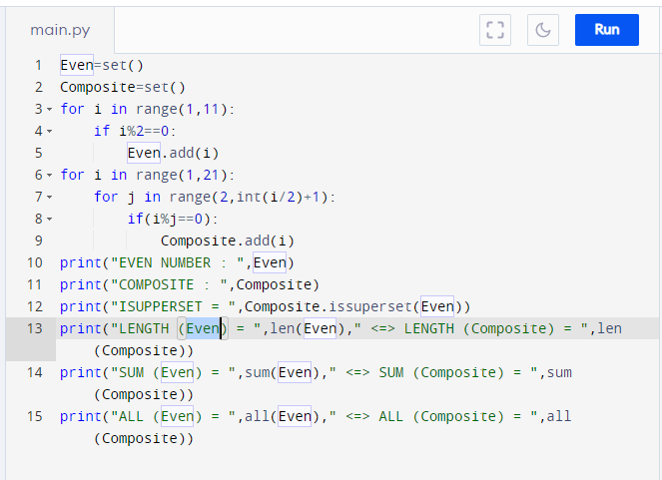

**OUTPUT**

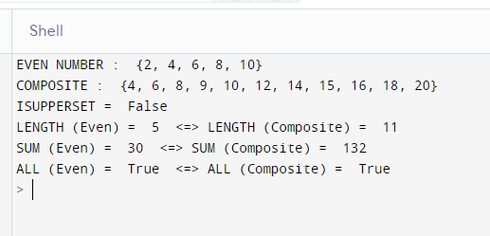

**NAME – PURUSHOTTAM KUMAR (2041)**